Fort Harrison PFAS Investigation Status Sheet
October 2025

Status: Extent and magnitude of PFAS impacts to media (soil, groundwater, sediment, & surface water) have been investigated but not fully delineated. Remaining data gaps will be addressed in the Feasibility Study (FS).

Preliminary Per and Polyfluorinated Alkyl Substances (PFAS) Groundwater Sampling Event – 2017
- Three monitoring wells FH-02, MW-06, and MW-08 were sampled for PFAS. Perfluorooctanoic acid (PFOA) and perfluorooctanesulfonate (PFOS) were detected but below 70 ppt.

Preliminary Assessment (PA) – 2018
- 14 potential areas of concern identified. PFAS attributed to Aqueous Film Forming Foam (AFFF) associated with fire training, fire response, fire truck washing, nozzle testing, surface dissipation into the Mount Defensa ditch, and pest control.

Site Inspection (SI) – 2019 - 2020
2019
- The potential release locations identified in the PA were investigated. 27 soil borings and 6 additional monitoring wells were installed in 2019.
- The 2019 PFAS soil concentrations were all below the Department of Defense (DoD) screening levels (SLs). See Table ES-1 Screening Levels. The highest PFOS concentration in soil was 22 ug/kg in soil sample AOI2-S2-0-2-DUP and the most elevated PFOA concentration was 0.473 ug/kg in soil sample AOI3-SB1-0-2.
- Groundwater samples were obtained from 15 wells (6 new, 8 existing monitoring wells, and 1 irrigation well). Only the sample from monitoring well AOI02-MW1 exceeded 70 ng/L for PFOS/PFOA. PFOS was 118 ng/L, and PFOA 10.7 ng/L, for a combined total of 128.7 ng/L.

2020
- The potential release locations were investigated. 27 soil borings and 5 additional monitoring wells were installed to evaluate impacts to soil and groundwater. 30 soil grab samples were obtained along with 15 groundwater samples. 5 groundwater samples were from the new monitoring wells and the other 10 from existing monitoring wells.
- The 2020 PFAS concentrations in soil were all below DoD SLs (see Table ES-1 Screening Levels). The highest PFOS concentration in soil was 39.9 ug/kg and the most elevated PFOA concentration was estimated at 0.166 ug/kg in soil sample AOI1-SS11-00-02.
- The 2020 analytical results from monitoring well AOI02-MW1 exceeded the Montana DEQ groundwater standard of 70 ng/L for PFOS/PFOA separately or combined with PFOS at 110 nanograms per liter (ng/L), and PFOA at 14.6 ng/L, for a combined total of 124.6 ng/L. Monitoring well AOI01-MW03 reported 62.2. ng/L PFOS and 14.3 ng/L PFOA. The combined value of 76.5 ng/L. The PFOS concentration exceeded the DoD SL of 40 ng/L. The results of the other 13 groundwater samples were below the DEQ-7 and DoD Screening Levels (SLs).

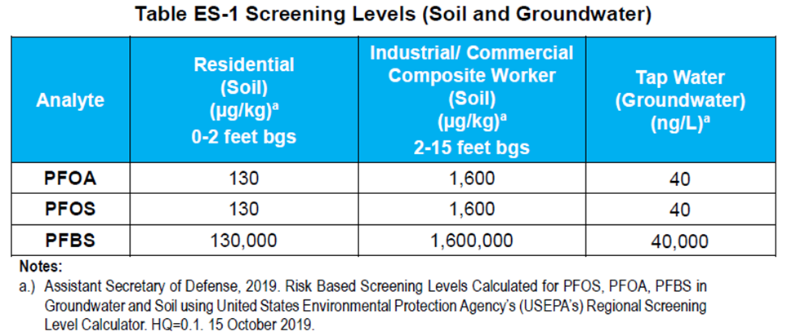

Remedial Investigation – 2021 - 2024
Mobilization 1 – 2021
- Rapid site characterization (RSC) was utilized to evaluate PFAS impacts in soil. 7 sampling Units (SUs) adjacent to release areas were established and sampled. The SUs were gridded, and 12 surface soil samples were obtained per SU for a total of 84 soil samples. Based on the RSC data, additional step out samples were obtained to further delineate the extent of soil contamination. PFOS was reported at a maximum concentration of 1,090 ug/Kg and PFOA reported 22.9 ug/L from SU-02. Soil samples from 2-4’ bgs reported detections of PFAS
- Vertical profiling (RSC) and grab-groundwater sampling. 6 vertical profile wells were installed, and 28 grab groundwater samples were obtained.
- Groundwater flow direction is generally eastward.

Mobilization 2 – 2022 to 2023
- The monitoring well network was expanded. 11 new wells were installed.
- Quarterly sampling of 35 wells was conducted for 4 events.
- Slug testing was conducted to estimate hydraulic conductivity and further refine the conceptual site model.

Mobilization 3 – 2024.
- The purpose of Mobilization 3 was to further define the horizontal and vertical distribution of PFAS in soil and groundwater.
    - 24 monitoring wells installed, including nested pairs
    - 53 soil samples were collected
    - 58 groundwater samples were obtained
    - 1 potable well was sampled
- Soil samples obtained from 0 -2‘bgs reported PFOA and PFOS exceeding the SLs presented in the Office of the Secretary of Defense (OSD) January 2025 PFAS memo (see Attachment A for the RSLs. The most elevated concentrations were 0.49 ug/kg PFOA and 5.8 ug/kg PFOS. PFAS results of soil samples collected from deeper intervals (7-9’ bgs and 13 -63’ bgs) were either non-detect or were below OSD SLs.
- Groundwater reported exceedances of PFOA, PFOS, and PFHxS SLs in most of the monitoring wells that were sampled. The maximum reported concentrations were 30.8 ng/L PFAO and 26 ng/L PFOS in monitoring well MW01D, and 681 ng/L PFHxS in monitoring well MW19.

Bottled Water Provision
- 5 residences downgradient of Fort Harrison reported drinking water exceedances in their domestic wells. Army National Guard started providing bottled water to these residences in 2023. I residence is still receiving bottled water. 1 residence previously installed a POET system and eventually declined additional water. 2 residences installed treatment systems and didn’t need additional water. 1 residence chose not to receive additional bottled water.
Next Steps
- Contractor is completing the RI Report with the understanding that there are data gaps in delineating PFAS in soil and groundwater. When data was screened to 2023 SLs, there were minor gaps in delineating soil and groundwater contamination. However, when the SLs were lowered in 2025, there were larger data gaps. These data gaps will be addressed under the Feasibility Study.
- The Draft RI is to be submitted to DEQ in November 2025.
- Proceed to Feasibility Study (FS). Additional data collection will not change the overall risk assessment conclusions. Tasks to be conducted under the FS include the following:
  - Conduct a data gap investigation.
  - Perform a background study.
  - Incorporate the data gap investigation results/background study in developing Remedial Action Objectives (RAOs).

